**Comp 3322 - Software Engineering**

**Final Project Report**

**Yusa Inc**

**Submitted by**

Ashwinder Chadha

Fahmi Yusa ILmana

**Computer Science**

**Dec 13, 2016**

**Table of Contents**

**1.1 Requirements Analysis**

1.1.1 Context of the project.

1.1.2 Explain the need and how this project will address it?

1.1.3 Who are the end users?

1.1.4 Software Product Features

1.1.5 Software Performance, Portability, Security

1.1.6 Database Requirements

1.2 Project Deliverables

**2 Project Organization**

2.1 Software Process Model

2.2 Roles and Responsibilities

2.3 Tools and Techniques

**3 Project Management Plan**

**3.1 Tasks**

3.1.1 Task-1 (For each task in mind map repeat this ..)

3.1.1.1 Description

3.1.1.2 Resources Needed

3.1.1.3 Dependencies and Constraints

3.1.2 Task-2

**3.1.2.1 Description**

3.1.2.2 Resources Needed

3.1.2.3 Dependencies and Constraints

3.2 Assignments

3.3 Timetable

**4 TEST**

4.1 Features Tested

4.2 Features not Tested

**5 ADDITIONAL MATERIAL**

5.1 Screenshots

5.2 Code

**INTRODUCTION**

**1.1 Requirements Analysis**

**1.1.1 Context of the project.**

## Yusa Inc is an e-commerce website

## Yusa Inc is an interactive website to promote the products of the company.

**1.1.2 Explain the need and how this project will address it?**

YUSA Inc is a cell phone accessory wholesaler, the firm supplies cell phone accessories to small scale retailers. Creating a website as proposed above would immensely help both YUSA INC and its customers in terms of ordering and generating invoices over the computer.

**1.1.3 Who are the end users?**

End users are people who are looking for phone cases for their phone.

**1.1.4 Software Product Features**

* Showcase of the products
* Sign up and Log in form
* MySql database
* Php
* Users will be able to buy phone case from the website.
* Interactive shopping cart

**1.1.5 Software Performance, Portability, Security**

Security over the users’ password with PHP blowfish encryption algorithm. Most of the computation occurs on the server side, most of the server are protected by firewall which keeps the code inaccessible to unauthorized users.

**1.1.6 Database Requirements**

We are using MySQL as our base database.

**1.2 Project Deliverables**

Deliverables on the 13th December 2016

**2 PROJECT ORGANIZATION**

**2.1 Software Process Model**

**Rapid application Development**

As a small team consisted of two people, the project has a large components that needs to be addressed. In that in mind we are actually started from zero knowledge of the languages we need to build the project. While learning and doing the project steps by steps, we use the rapid application development to meet the deadline. The whole project was made in small pieces. Each piece was first porotype at a small scale .Then next step was to combine one prototype of the website to another prototype. When all the parts of the website where ready they were assembled together into a single entity.

**2.2 Roles and Responsibilities**

**Ashwinder Chadha**

* Back End
  + Create Database.
  + Create and authenticate PHP login and sign up form.
  + Create shopping cart
  + create panel
  + encrypt user data

**Fahmi Yusa ilmana**

* Create Front end website
* Create slideshow
* Create login and sign up html form

**2.3 Tools and Techniques**

- Html5

- CSS

- PHP

- Javascript

- MySQL

- Bootstrap

**3 PROJECT MANAGEMENT PLAN**

**3.1 Tasks**

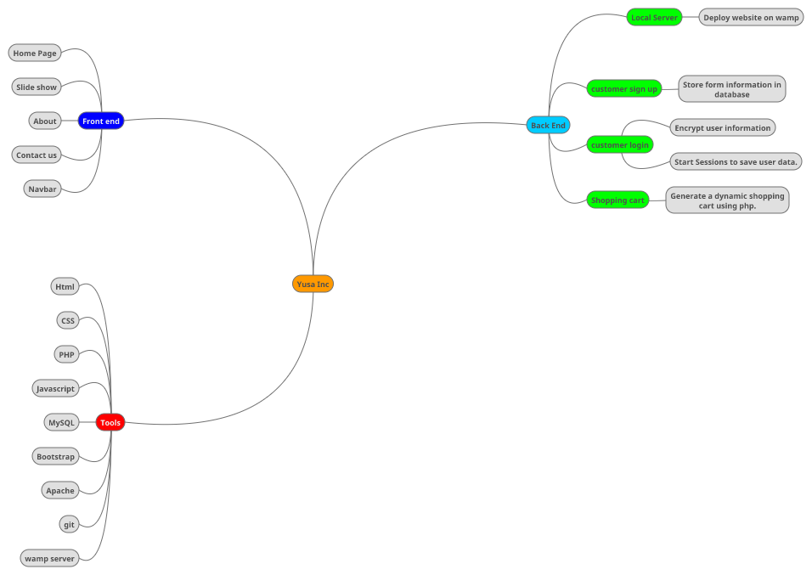

**3.2 Assignments**

**Ashwinder Chadha**

* Back end development of the website
* Learn to deploy website on a local server
* Test project
* Learn PHP, MySQL, JavaScript, CSS, HTML
* Create database and add relations/constraints amongst tables.

**Fahmi Yusa ilmana**

* Front end development of the website
* Learn Html, CSS, bootstrap, JavaScript

**3.3 Timetable**

|  |  |  |
| --- | --- | --- |
| **Task** | **Start Date** | **End date** |
| 1.0 Planning |  |  |
| 1.1 Subtask 1 |  |  |
| Come up with an idea, name for the project, Design, and outline | September 23, 2016 | September 25, 2016 |
| 1.2 Subtask 2 |  |  |
| The group decided on tasks and distributed them between members of the group according to their skills and knowledge. | September 25, 2016 | November 3, 2016 |
| 2.0 Analysis |  |  |
| 2.1 Subtask 1 |  |  |
| The group in process to decide which tools will be used. | September 28, 2016 | November 4, 2016 |
| 2.2 Subtask 2 |  |  |
| Designing the layout of the website on paper. | November 5. 2016 | November 7, 2016 |
| 3.0 Design |  |  |
| 3.1 Subtask 1 |  |  |
| Create a template design for website.  Design database. | November 6, 2016 | November, 12, 2016 |
| 3.2 Subtask 2 |  |  |
| Company logo, menu, slideshow, etc. on the home page are designed. | November 10, 2016 | November 16, 2016 |
| 4.0 Implementation |  |  |
| 4.1 Subtask 1 |  |  |
| Yusa is on the task of creating the front end of the website, using HTML, CSS, and bootstrap | November 10,2016 | December 9, 2016 |
| 4.2 Subtask 2 |  |  |
| Ashwinder is on the task of implementing the back end of the website, using PHP, MySQL, | November 10,2016 | December 10, 2016 |
| 5.0 Testing |  |  |
| Testing on Ashwinder Laptop, use his own laptop as database using wampserver. | December 5 | December 10,2016 |
| Final test of how website works | December 9, 2016 | December 10, 2016 |
| 6.0 Deployment |  |  |
| 6.1 Yusa inc website | December 10,2016 | - |
| 6.2 Final Presentation of Project | December 13,2016 | - |

**4 TEST**

**4.1 Features Tested**

Test on the website pages. Sign up and login form. Shopping cart page. Data retrieval from database. User authentication.

**4.2** Features not tested

Website was not deployed on a mobile device.

**5 ADDITIONAL MATERIAL**

**5.1 Screenshots**

**5.2 Code**